AI-DNA Startup (Laws)

Introduction
In today's era of advanced healthcare and AI, handling patients’ data is governed by complex laws, spanning traditional healthcare to artificial intelligence (AI) regulations. These laws protect patients' privacy, secure data for access and storage, and ensure ethical use of their information while safeguarding healthcare companies from cyber threats and breaches. I will explore 5 crucial laws that shape data governance and management in predictive genomic DNA profiling organizations. I categorized the following laws into healthcare, AI, and international groups.

Health Insurance Portability and Accountability Act (HIPAA)
The Health Insurance Portability and Accountability Act (HIPAA) is among the most important healthcare laws in the United States. HIPAA protects health information by establishing privacy rules to protect the health information of individuals and organizations. Healthcare providers must get patient consent for data access, and sharing, and ensure any disclosures are made with the patient's knowledge and authorization. This law gives patients’ rights over their data, enhancing their control and privacy (CDC, 2024).
The privacy rule cited in 45 CFR limits e-PHI use and disclosure without patients’ knowledge or authorization. The security rule in the same section details administrative, physical, and technical use of electronic sharing of patient information (Cornell Law School, 2024). These standards ensure confidentiality, integrity, and availability of data. The regulation covers health information created, stored, transmitted, or received electronically, including medical histories, treatments, and other health-related data.
HIPPA will enable AI-DNA to protect patients’ data and comply with regulations on consent and privacy. Their notification feature will help the company proactively deal with breaches and cyber security threats. This compliance framework will include risk assessment, administrative and physical control, protecting the company and the patients. AI-DNA can utilize business associate agreements which will force third parties to adhere to HIPPA’s way of handling electronic data sharing, protecting genomic data throughout its lifecycle.

Health Information Exchange (HIE) Laws
Health Information Exchange (HIE) laws regulate the electronic sharing of health information among healthcare providers and organizations within individual states. HIE improves care coordination, patient care, and outcomes, and reduces healthcare costs by securing efficient exchange of patient information. All states adhere to consent requirements, data privacy and security standards, and data governance structures for operations. The implementation might differ from state to state based on the nature of the data and state laws. Some states implement different consent such as opt-in or opt-out modes. However, all states ensure transparency in data-sharing practices and follow federal privacy and security requirements that protect the integrity and confidentiality of patient data (HealthIT.gov, n.d).
HIE will help AI-DNA by facilitating data access and integration, promoting interoperability that enables easier integration of various sources, and enhancing research and collaboration that will lead to precision medicine, disease prediction, and prevention, and create robust treatment plans. It will also protect patients’ data through consent and privacy while complying with industry standards, thus mitigating risk. This will eventually lead to AI-driven solutions in genomic research, personalized medicine and treatments, and optimizing healthcare practices with legal and ethical standards.

Genetic Information Nondiscrimination Act (GINA)
The Genetic Information Nondiscrimination Act of 2008 protects people from genetic discrimination in health insurance and employment. Insurance companies cannot use genetic information to offer premium prices based on an individual’s conditions. It also restricts insurance companies from requesting or requiring genetic tests before quotes and enrollment. The second clause of GINA protects employees. Employers are prohibited from requesting genetic testing or purchasing genetic information from their employees or families.
The genetic information under GINA includes details about genetic tests or either individual or family members, medical history, and treatments. It covers diseases, disorders, and any traits that are genetically predisposed.
All companies handling genetic data must implement data protection measures to protect confidential information, ensure data encryptions, and prevent unauthorized access or breaches. AI-DNA must enforce ethical guidelines in handling data and engaging with investors, researchers, and policymakers. It must align business practices with ethical standards and compliance with the law. AI-DNA will foster trust and creditability in innovative technologies by enforcing and implementing GINA laws.

EU General Data Protection Regulation (GDPR)
The General Data Protection Regulation is implemented across European Union countries. It protects individuals’ privacy and gives control over their data. Although not exclusively related to healthcare, it includes health information within its scope of personal data protection. This ranges from insurance, medical records, and treatment history. GDPR mandates that organizations lawfully obtain consent from individuals for processing sensitive information and uphold subject rights regarding access, disclosure, and data transmission (GDPR.eu, 2023).
AI-DNA has the potential to be a global company. It must get explicit consent from individuals in Europe before processing their genetic information. GDPR grants rights such as access to data, the ability to correct data discrepancies, requests to delete certain data, restricting processing, and requests to transmit data. AI-DNA must anonymize the data collected to protect individuals’ identities. It must report any data breaches or potential risks to authorities within 72 hours. To ensure compliance, AI-DNA must allocate resources for compliance audit, data protection, and train the data services team on GDPR.

Ethical, Legal, and Social Implications (ELSI) Research Program
This program is part of the National Institute of Health Human Genome Project. It highlights ethical, legal, and social issues that can affect quick advances genetic research. It enforces that genetic research is ethically conducted and complies with social and legal laws. ELSI prevents discrimination by implementing policies that protect individuals from unfair treatment based on genetic information. It emphasizes patenting genetic discoveries and protecting the intellectual property of the researchers (NIH, 2020). Like the other laws, it protects individuals’ privacy, consent, and confidentiality information.
AI-DNA will benefit from ELSI guidelines. As a company, it must adhere to ethical guidelines aligning with ELSI. It must ensure data privacy and confidentiality of genome data, get consent from individuals, and address any inequalities. AI-DNA must understand intellectual property law, which will help their researchers gain credit for their work. By following these guidelines, AI-DNA will consider social implications such as how their research can contribute to health or social inclusion or inequalities. Demonstrating commitment to ethical, social, and legal considerations will build trust with the public.

Conclusion
All the above laws collectively establish frameworks for effectively handling health data, focusing on patients’ consent, privacy, and security. They all enforce data security, ethical standards, and compliance with the bodies that govern them. Adherence to these laws will set AI-DNA as an innovative health technology company while safeguarding patients’ trust and their data.

AI-DNA Startup (Polices and Measures)

Health Insurance Portability and Accountability Act (HIPAA)
AI-DNA must observe the following policies and procedures to comply with HIPPA: patient privacy, data security, access control, breach notification, training and education, audit and monitoring, data minimization, third-party agreements, incident reports, and patient rights.
AI-DNA must implement protocols to ensure patient information protection, and only authorized individuals can access it. Confidential agreements and training programs will help employees understand the importance of privacy. Encryption and secure communication channels will enhance privacy and secure patients’ data.
Firewalls, encryption, multi-factor authentication, and password control will protect information shared electronically. AI-DNA must regularly conduct risk assessments to improve, mitigate, and solve vulnerabilities.
Defining roles, resources, and clearance will ensure that only authorized employees can access data. This will in turn control access and sharing capabilities. AI-DNA must implement access logs and audits to monitor or review access over time. Fired employees must be restricted from accessing data and physical buildings.
AI-DNA must establish procedures for identifying breaches and notifying data services teams and authorities. Proper incident reports and responses will serve as a guideline to employees. The affected individuals will receive training and education on cyber security threats and HIPPA regulations. The company should provide a refresher course on data security and HIPPA regulations to ensure compliance and best practices.
The data services team will conduct audits to monitor systems and processes. These tools will detect unauthorized access, suspicious activities, and potential risks. This will help with data minimization where only required information will be sent out. Implementation of de-identification and anonymization of data will be crucial for electronic shared data.
The above policies collectively help AI-DNA maintain the confidentiality and integrity of patient data. AI-DNA can measure the effectiveness of the policies by checking for training completion rates, data breach incidents, access logs, patients’ complaints, and policy adoption rates. Patients’ reviews, audit reviews, and case studies will also measure the effectiveness of the policies.

Genetic Information Nondiscrimination Act (GINA)
The crucial policies and procedures that AI-DNA must observe are non-discrimination of employment, non-discrimination in health insurance, genetic testing consent, data security, training and awareness, violation reporting, record keeping, audit and compliance, and public awareness campaigns. These policies will promote awareness and protect confidential information (US Govt., n.d).
AI-DNA will not use genetic information to decide on hiring, firing, promoting, or other job-related activities. It will also prohibit hiring managers from requesting or requiring genetic information about job applicants.
AI-DNA will treat all its employees with dignity and equity. I will not reject health insurance or charge premium rates based on an employee’s genetic predisposition. All employees will be eligible for coverage and company health benefits.
All the genetic information will be confidential and in compliance with GINA. Only authorized personnel will access collected, stored, and transmitted data. All the employees will go through a rigorous background check to ensure the credibility and security of the data and personnel.
AI-DNA will obtain written and verbal consent for genetic testing of individuals. All patients will be fully informed of the nature of the test, its purpose, risks, and how their data might be used to inform research. The physicians will detail all the side effects and potential results implications.
AI-DNA will enhance its data security practices and create robust security measures to protect data against breaches, cyber threats, and unauthorized access. They must implement encryption, a secure storage system, secure transmission, and access control against outside parties. Audits will expose potential gaps and drive process improvement.
The company must invest in reporting mechanisms and training for employees. Each stakeholder must receive regular training on GINA regulations and their responsibilities to ensure compliance. Every employee must understand how to handle confidential information and can report in case of violation or system failure. Public awareness campaigns will help create fair and equitable environments for employees and patients. These programs will include community outreach, partnerships with advocacy groups, and informational campaigns to enhance transparency on AI-DNA practices.
AI-DNA will measure discrimination cases, the number of training sessions offered, violation reports, consent forms collected, data breach incidents, and the number of campaigns and interviews from patients and employees to observe compliance with GINA.

Ethical, Legal, and Social Implications (ELSI) Research Program
AI-DNA will implement policies to address informed consent, privacy and confidentiality, data sharing agreements, ethical review, community engagement, risk assessment, cultural sensitivity, and transparency.
AI-DNA will provide clear and detailed information on consent forms. They will use simple and easy-to-understand language to allow clarification and participation without coercion. To safeguard personal and sensitive information, AI-DNA will secure data storage systems with restricted access. They will train research on data privacy, data access, and transmission.
Data-sharing agreements will establish transparency while protecting confidential information. AI-DNA will establish clear data-sharing agreements, de-identify data before sharing, and ensure that only authorized personnel can access the data. This policy will help identify, disclose, or manage potential conflicts of interest while maintaining data integrity.
Community engagement, participants' feedback, and ethical review policies will establish trust within the community, industry, and patients. AI-DNA will submit detailed research to the ethics review committee. They will allow peer reviews of their experiments and periodic reviews of ongoing research for continued ethical compliance. The company will share findings with the public in accessible formats and encourage community feedback.
AI-DNA will use survey completion rate, participation retention rate, community participation, cultural competency training, focus groups, and ethics committee feedback to measure the effectiveness of company policies. All the above policies enhance data assets, communication, transparency, and ensure compliance with the rules and regulations outlined throughout the paper (Twilio Segment, 2024).

AI-DNA DATA GOVERNANCE STRUCTURE
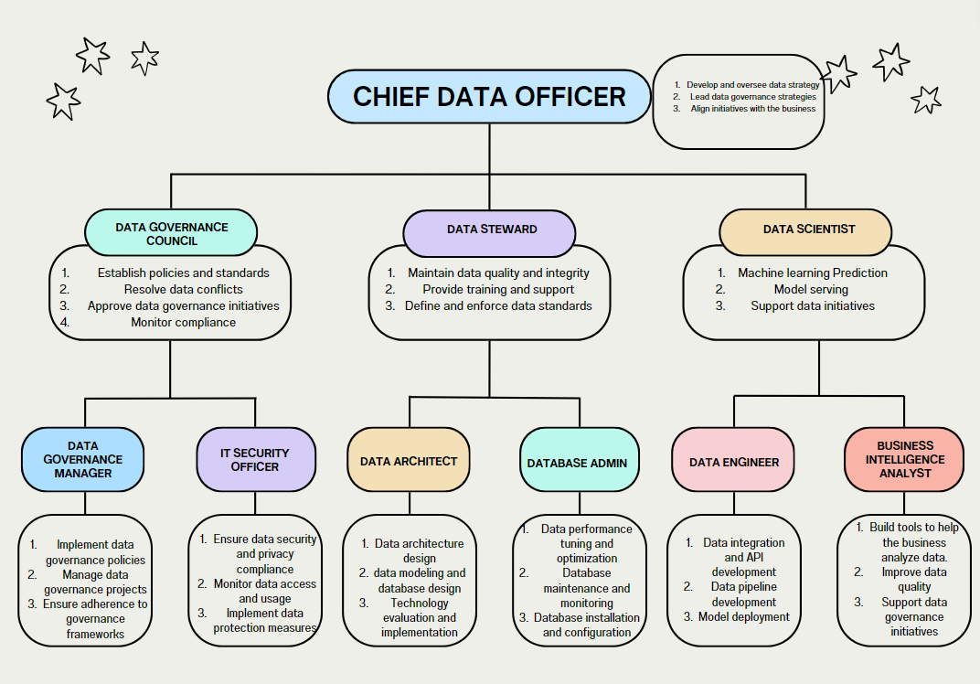
References
CDC. (2024, May 13). Health Insurance Portability and Accountability Act of 1996 (HIPAA). Public Health Law. https://www.cdc.gov/phlp/php/resources/health-insurance-portability-and-accountability-act-of-1996-hipaa.html
Cornell Law School. (2024). 45 CFR § 160.103 - Definitions. LII / Legal Information Institute. https://www.law.cornell.edu/cfr/text/45/160.103
GDPR.eu. (2023, September 14). What is GDPR, the EU’s new data protection law? https://gdpr.eu/what-is-gdpr/
HealthIT.gov. (n.d.). Health IT and Health Information Exchange Basics. https://www.healthit.gov/topic/health-it-and-health-information-exchange-basics/what-hie
NIH. (2020). Ethical, Legal, and Social Implications in the All of Us Research Program. All of Us Research Program | National Institutes of Health (NIH). https://allofus.nih.gov/sites/default/files/ELSI_White_Paper.pdf
Twilio Segment. (2024). What is a data governance policy? Examples + templates. https://segment.com/data-hub/data-governance/policy/
US Govt. (n.d.). The Genetic Information Nondiscrimination Act of 2008. US EEOC. https://www.eeoc.gov/statutes/genetic-information-nondiscrimination-act-2008

